Pearl of The North 9th Annual Event
Saturday 22nd October 2022
Tapuwaetahi Beach, Te Tii

Hosted by Kaihoe o Ngāti Rēhia – Waka Ama Club

EVENT SUMMARY
Tēnā koutou katoa,

Kaihoe O Ngati Rehia Trust – Waka Ama Club invite you all to participate in our 9th Annual Pearl of the North event, at Tapuwaetahi Beach. We have missed seeing all our waka whānau and unfortunately we had to cancel last years event, but we are very excited and very much so looking forward to hosting another epic event.

The course is designed to be inclusive to Novice as well as seasoned paddlers.
Tapuwaetahi has a unique contour, in which we can incorporate short, medium or long distance.
The water is divine and the spectators can take in the action for most part of the event.

We look forward to seeing you all x

EVENT SCHEDULE

7.00am | Waka drop off & safety checks
8.00am | Registration
9.00am | Whakatau & Race and Safety briefings
9.30am | Race 1: W6 24km
 | Race 2: W6 10km
 | Race 3: W1 5km, W2 5km, W1 10km, W2 10km
2.00pm | Races Finish
2.15pm | Karakia Whakamutunga

RACE SCHEDULE

Time | Race
9.00am | Race Briefing - all races
9.30am | Race 1 Start – W6 24km  (J19, Opens, Masters, Snr Masters, Golden Masters)
Race 2 Start - W6 10km

(J16, J19, Opens, Masters, Snr Masters, Golden Masters)
Race 3 Start – W1 and W2
5km and 10km

RACE DAY INFORMATION

Car Parking: Parking is limited down at the beach. If possible, please try your best to carpool to reduce traffic as this is also a residential area. We are also hoping to have parking available up at Te Tii school, to minimise the traffic down to Tapuwaeahi (tbc).
Trailer parking: Trailer parking will be available down at the beach. You will be directed by kaimahi and signage will be visible.
Food: We encourage you to bring your own kai. Also keep an eye on the Kaihoe o Ngāti Rēhia page as we may add some kai vendors for the day.
Toilets: Toilets will be visible at the venue.
First Aid: First Aid will be available at the registration tent.
Rubbish/Recycling: We encourage you to please take what you bring. However, the main rubbish and recycling station is located near the registration tent.
Alcohol/Smokefree: Alcohol, smoking, vaping and any other substance use is not permitted at this event.
Accommodation: Will be available at Hiruharama Hou Marae, Te Tii. Please contact Daniel Kaiawe for more information.

WAKA DROP OFF & SAFETY CHECKS

Waka Drop off:
- Waka drop off will be available from 7.00am on the event day.
- Waka drop off will be on the beach front landing and will be clearly signed with entry & exit
- Trailer parking will be near drop off area. Signage will be visible.
Safety Checks:
- All waka will have to pass a safety check and be marked before racing. Any boats not marked
will not be permitted to race.

RACE RULES

All entrants must be familiar with the Waka Ama New Zealand race and safety rules.
Refer to the following link for more information: Waka Ama NZ Race Rules

AGE DIVISIONS & RACE EVENTS

WAKA | DISTANCE | DIVISIONS | GENDER
W1/W2 | 5km and 10km | J16, J19, Open, Master, Senior Master, Golden Master | Men & Women
W6 | 10km | J16, J19, Open, Master, Senior Master, Golden Master | Men, Women, Mixed
W6 | 24km | J19, Open, Master, Senior Master, Golden Master | Men, Women, Mixed

FEES

PER PERSON BY RACE DIVISION
Race Division | Cost
Race 1 - W6 24km | $50.00pp
Race 2 - W6 10km | $40pp
Race 3 - W1/W2 | $40pp (Paddlers that enter Race 1 W6 24km & Race 2 W6 10km races will get free entry for  themselves into Race 3 W1 5km or W2 5km or W1 10km or W2 10km. You must still process your entry)

ONLINE ENTRIES & PAYMENT

- Online entries are to be completed using the Waka Ama NZ online entry system. https://wakaama.co.nz/racecalendar/lookup/2015
- All entries to be completed through your club admin – contact your club admin to process your entry
- No entries on the day, no exceptions
- Entries close on Tuesday 18th October 2022 at 11.59pm
- Rosters close on Wednesday 19th October 2022 at 11.59pm, rosters must be completed by close date, no exceptions
- Once entered, payment can be made online to:
- Kaihoe O Ngati Rehia Trust
- Acc 12 3091 0219174 00
- Code: POTN22
- Use your club, team name and division as your reference

SAFETY REQUIREMENTS

- All waka must be Safety Checked
- All Junior (J16 & J19) and Senior (Open and above) must have the following safety equipment for their races:
  - PFD - Personal Floatation Device (per person)
  - Bailers
  - Flare or cellphone in waterproof case
  - Spare Paddle - 2 for a W6, 1 for W1/2
  - Spray Skirt (W6)
  - Tow Rope (W6)
  - Leg leash (for sit on top W1)

INDIVIDUAL & TEAM WAIVERS
- Individual and Team waivers must be completed by all paddlers/teams
- All paddlers U18 must have their waiver signed by their parent/guardian
- Waivers can be sent to kaihoengatirehia@gmail.com or handed in on the day.
- Individual & Team waivers can be found here: https://wakaama.co.nz/racecalendar/lookup/2015
CONTACT INFORMATION

- All enquiries please email: kaihoengatirehia@gmail.com
- All urgent matters please call: Daniel Kaiawe 021958378
- Facebook: https://www.facebook.com/groups/156538157714816/

COURSE MAPS
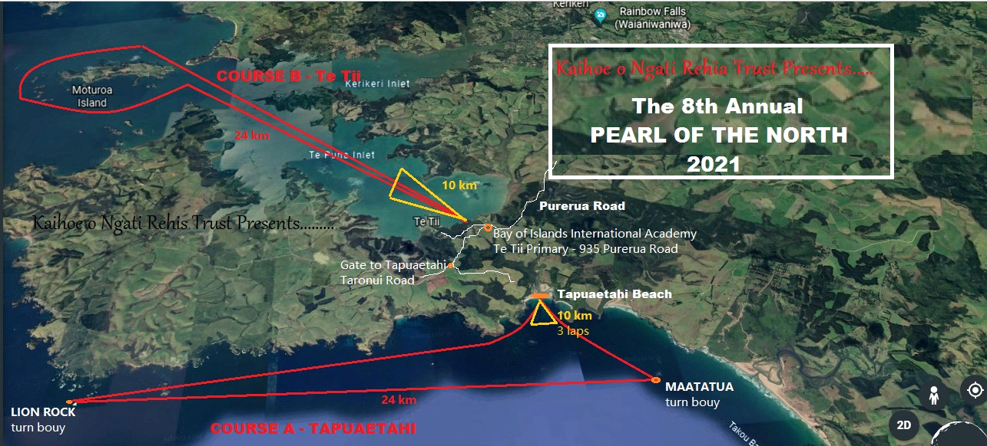
Kaihoe o Ngāti Rēhia Trust Presents….

The 9th Annual
Pearl of the North
2022

- High tide: 4:46am
- Low tide: 10:55am

